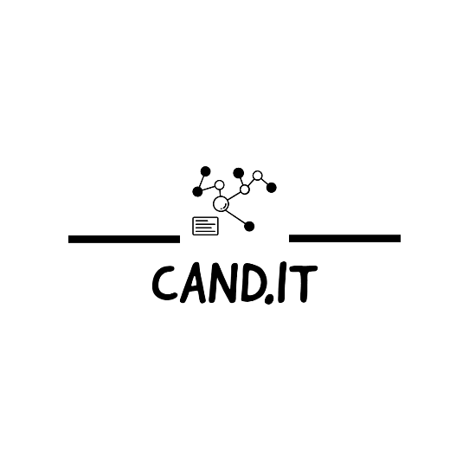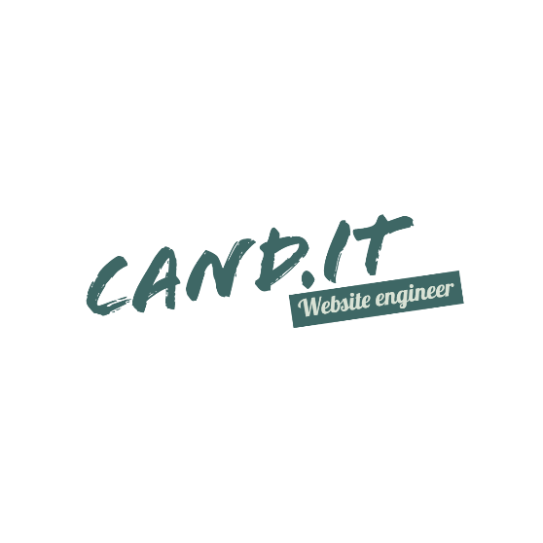

**FOR MORE INFO**

**+254798908146**

**WEBSITE DESIGNING**

**TRANSFORM YOUR ONLINE PRESENCE**

**WEBSITE DEVELOPMENT AND MAINTAINENCE**

**WEB HOSTING AND DOMAIN SERVICES**